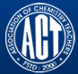 Association of Chemistry Teachers (ACT)
C/o. Homi Bhabha Center for Science Education (HBCSE), TIFR, Mumbai-400 088
News Letter Issue-4/ January - April, 2016
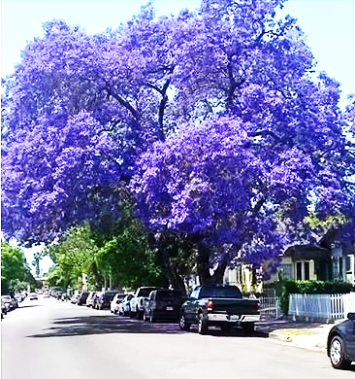

Editor’s Voice
Sincere efforts have been made to provide information through this issue which is varied and vivid, for the benefit of ACT – Members, to get them acquainted with the rare information made readily available for their information. The objective of this News Letter is to acquaint the readers on the latest advancements taking place in various fields of science & technology. This also enables one to re-orient their research plans so as to achieve greater heights in their research pursuit. Any valuable comments and suggestions from the readers are solicited to imrove the standards of this News Letter.
With warm regards & best wishes to one and all
Dr. M. R. R. Prasad
--------------------------------------------------------------------------------------
Nobel Laureates in Chemistry – 2015
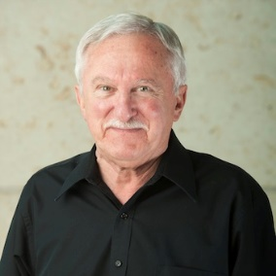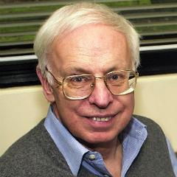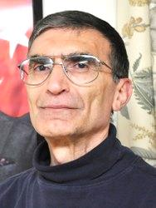

The Royal Swedish Academy of Sciences has decided to award the Nobel Prize in Chemistry for 2015 to

Tomas Lindahl, Swedish Citizen
Born: 1938 in Stockholm, Sweden
PhD – 1967 from Karolinska Institute, Stockholm, Sweden
Professor of Medical and Physiological Chemistry at University of Gothenburg 1978 – 82
Emeritus Group Leader at
Francis Crick Institute and Clare Hall Laboratory, Hertfordshire, UK

Paul Modrich, U. S. Citizen
Born: 1946
PhD – 1973 from Stanford, CA, USA
Investigator at Howard Hughes Medical Institute and Duke University School of Medicine, Durham, NC, USA

and

Aziz Sancar, U. S. and Turkish Citizen
Born: 1946 in Savur, Turkey
PhD – 1977 from University of Texas, Dallas, TX, USA
Sarah Graham Kenan Professor of Biochemistryand Biophysics
University of North Carolina, Chapel Hill, NC, USA

“for mechanistic studies of DNA repair”.
----------------------------------------------------------------------------------------------------------------------------------------------------

ACT – Activities:
- On January 13, 2016, Dr. M. R. R. Prasad gave an invited talk at the Applied Chemistry Department of the Maharaja Shaojirao University, Vadodara.

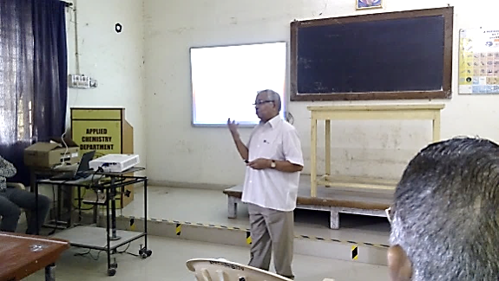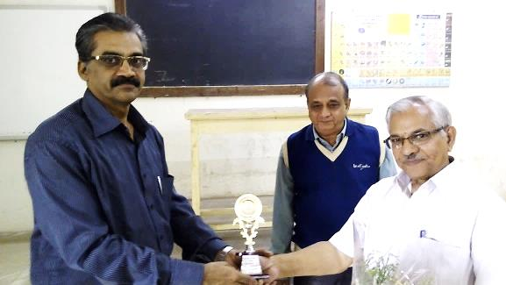

- January 30, 2016

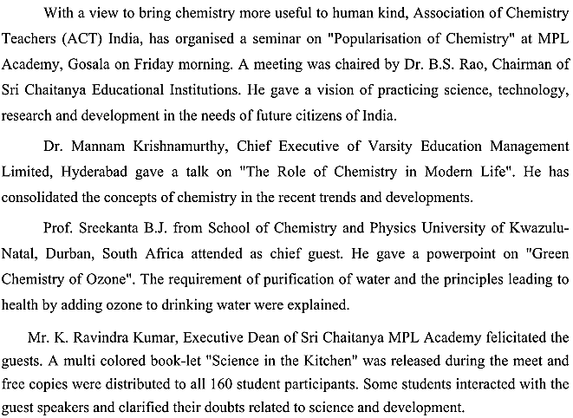
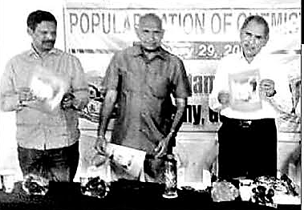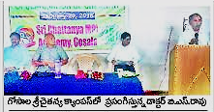

- Invited talk on “Recent Trends in Science and Engineering Research” was delivered by Emeritus Professor, M. Swaminathan at Faculty Development Program organized by the Centre of Learning, Technology & International Research Centre, Kalasalingam University during January 27th -29th, 2016.

- Invited talk on “Photo-catalysis for Dye Industrial Effluent Treatment,” was delivered by Emeritus Professor, M. Swaminathan to M. Tech., and Ph. D students at the Center for Nano-science and Technology, Pondicherry University, Pondicherry, on 19th February, 2016.
- On March 12, 2016, ECM – 1 of ACT (2015-2016) was held at HBCSE, Mumbai at 10 A.M,
under the Chairmanship of Prof. (Dr.) S. D. Samanth, President – ACT.
- An invited talk on “Photo-catalysis and Photo-reactor for Multiple Applications,” was delivered by Emeritus Professor, M. Swaminathan, at a State-level Workshop on Applications of Photo-reactors, organized by Sarah Tucker College, Tirunelveli, on March 17^{th, 2016.}
- On March 29, 2016, Dr. Hemanth Pande Organized an IRIS Workshop for school children, and a Science & Technology Innovations program for B. E. (Part-I) students of Sri gajanan Maharaj College of Engineering, Shegaon with the support of Dr. Kharate and Dr. Patil.

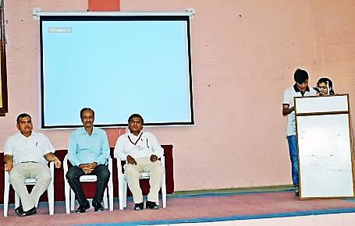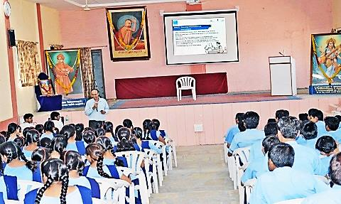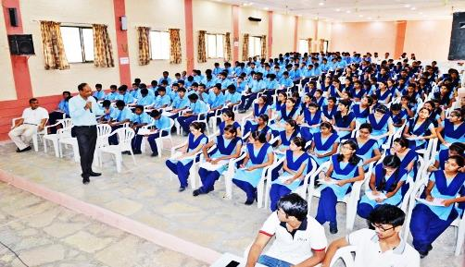

Department of Chemistry, College of Arts, Science and Humanities, Modi University, Lakshmangrah Sikar - 332311, Rajasthan has organized INST OUTREACH PROGRAMME FOR POPULARIZATION OF SCIENCE, Chattra Protshahan Vyakhyan Shrankhla (CPVS), on April 09, 2016, Co-ordinated by Prof. Amlan Kumar Das. Prof. Ashok K Ganguli, Director, Institute Nano Science and Technology, Mohali, Chandigarh, delivered two lectures titled- “Imagine life without science” and “Nano Technology in nature and for the future” on this occasion. This was followed by student interaction. Around 400 students (IX, X, XI, XII, B.Sc. and M.Sc.) participated in the outreach program from the nearby schools and colleges.
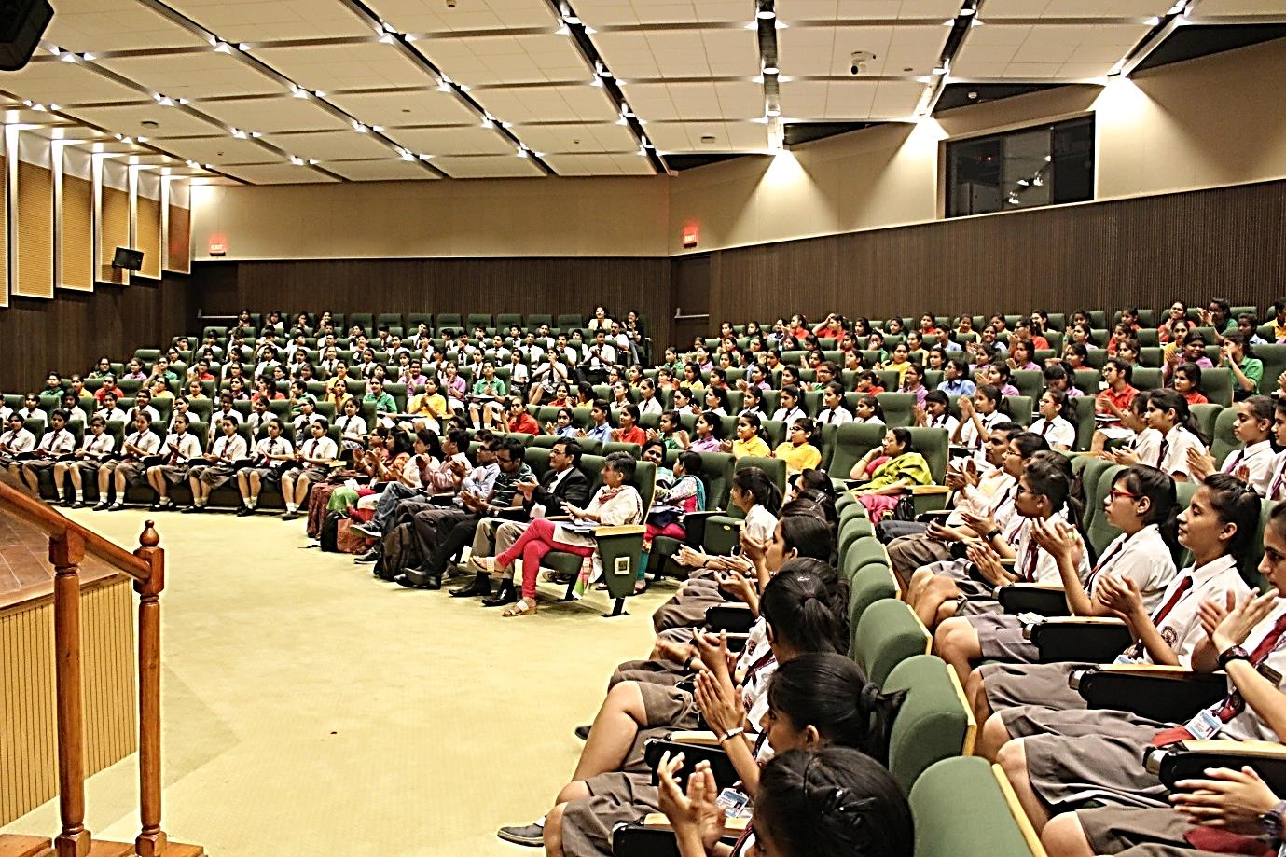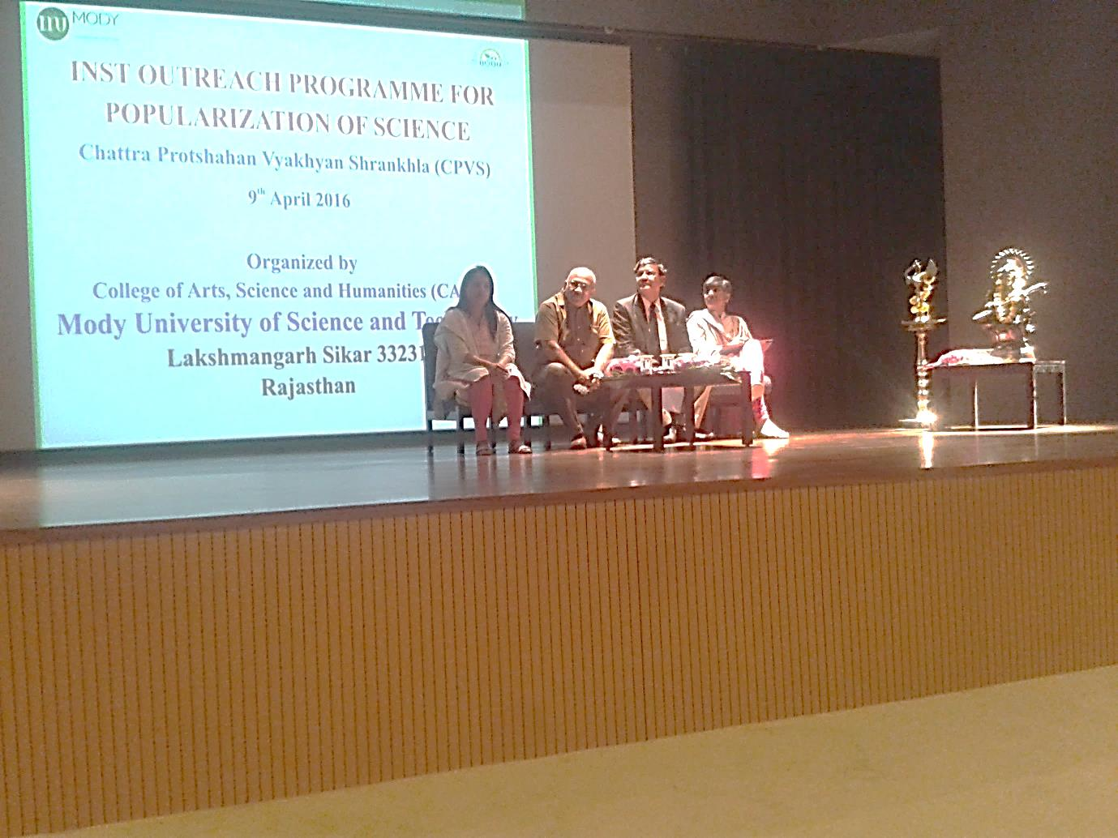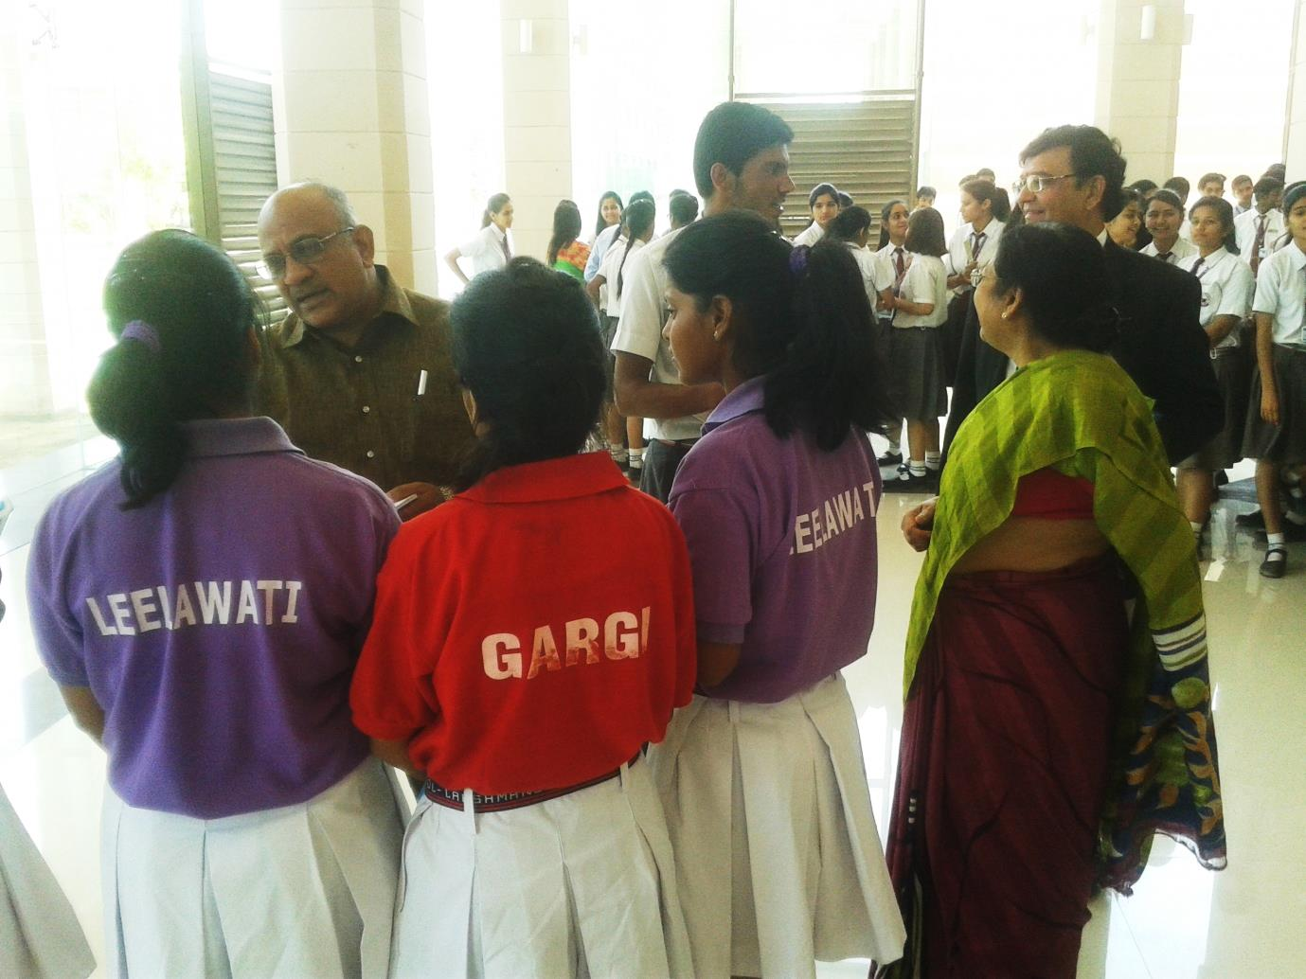
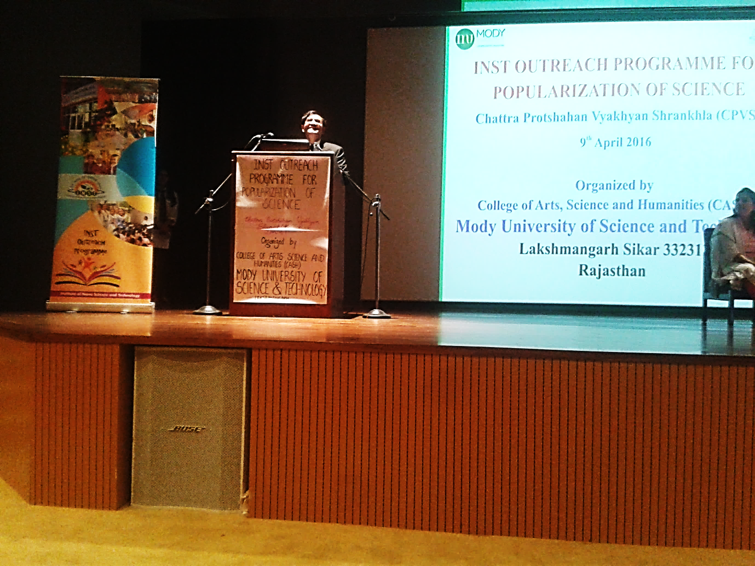
- Department of Chemistry, College of Arts, Science and Humanities, Modi University, Lakshmangrah Sikar - 332311, Rajasthan organized a popularization workshop on Emerging Technologies based on Nanoscience,” during April 22 – 23, 2016, coordinated by Prof. Amalan Kumar Das. The invited speakers include - Prof. A. K. Ganguli, Convener, FASc, FNASc , Director, Institute of Nano Science and Technology, Mohali; Prof. A K Tyagi, FASc, FNASc, Department of Chemical Science, BARC Mumbai; Prof. Ratnamala Chatterjee, Department of Physics, IIT Delhi; Dr. Jiban Jyoti Panda, Institute of Nano Science & Technology, Mohali.
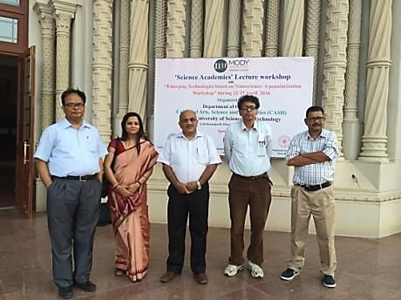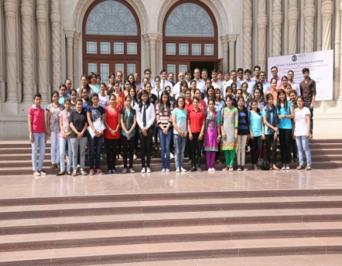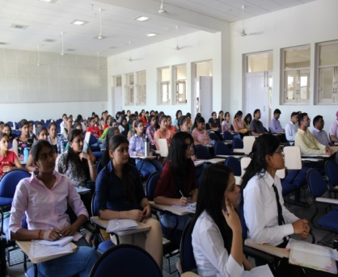
- On April 29, 2016 a flag off ceremony at Indo – US Science and Technology Forum for Children representing India at Intel International Science and Engineering Fair was held. These children will present their innovative research, competing with about 2000 students from 80 countries.
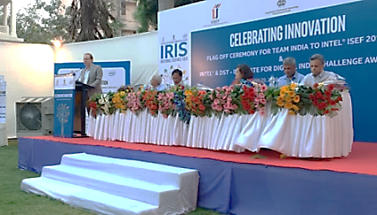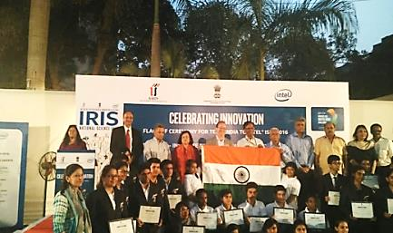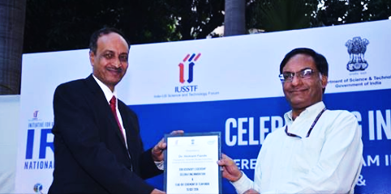

- Valedictory Function of Orientation – cum – Selection Camp (OCSC) for selection of the team to represent India at the 48th International Chemistry Olympiad – 2016 was held on April 22, 2016 at HBCSE, TIFR, Mumbai.
Dr. Ankush Gupta of Chemistry Cell, HBCSE was the Co-ordinator of the Camp and did a commendable job of planning and organizing the camp. All the members of the Chemistry Cell led by Prof. Savita Ladage, Mrs. Swapna Narvekar, and Mrs. Indrani das Sen, gave valuable help and support making the camp a great success.
The IChO – 2016 will be held in Tibilisi, Georgia from July, 23 – August 01, 2016. Preparations for selecting the team began in November, 2015. About, 39,000 students participated across the country for the first- level examination conducted by the Association of CHEMISTRY Teachers (ACT). At the 2nd – level examination of Indian National Chemistry Olympiad (INChO) which was conducted at 18 centres across the nation, 402 students were selected.

From this group 38 students were selected for participation in the intensive training camp towards participation in the International Chemistry Olympiad, i.e., Orientation – cum – Selection Camp (OCSC) conducted at the Homi Bhabha Centre for Science Education (HBCSE), TIFR, Mumbai, during April 13 – 22, 2016. Through a rigorous selection procedure consisting of theoretical and experimental examinations a team of 4 students was announced on the last day, during the valedictory function held on April 22, 2016, with Prof. Arvind A. Natu of Indian Institute of Science Education and Research (IISER), Pune as the Chief Guest.

- The names of the selected candidates are:
- Kartik Patekar – Indore
- Sharvik Mital – Bhopal
- Utkarsh Gupta - Guna
- Valay Agarawal - Jaipur
- The team will be accompanied by two leaders:
- Prof. A. A. Natu, IISER, Pune and Prof. Avinash Kumbhar, University of Pune, Pune
and, two scientific observers:
- Prof. Anindya Dutta, IIT – Mumbai and Dr. Ankush Gupta, HBCSE, TIFR, Mumbai.
ACT wishes all of them the very best and Good Luck.

- 48th International Chemistry Olympiad (IChO) Team for 2016:
The IChO – 2016 will be held in Tibilisi, georgia from July, 23 – August 01, 2016. Preparations for selecting the team began in November, 2015. About, 39,000 students participated across the country for the first- level examination conducted by the Asssociation of CHEMISTRY Teachers (ACT). At the 2nd – level examination of Indian National Chemistry Olympiad (INChO) which was conducted at 18 centres across the nation, 402 students were selected. From this group 38 students were selected for participation in the intensive training camp towards participation in the International Chemistry Olympiad, i.e., Orientation – cum – Selection Camp (OCSC) conducted at the Homi Bhabha Centre for Science Education (HBCSE), TIFR, Mumbai, during April 13 – 22, 2016. These students represent some of the most talented students of the nation. Finally, from this core team, a creamy layer of 4 were selected on the last day, during the veledictory function of the training camp which was held on April 22, 2016, with Prof. Arvind A. Natu of Indian Institute of Science Education and Research (IISER), Pune as the Chief Guest. The names of the selected candidates include:
Kartik Patekar - Indore
Sharvik Mital - Bhopal
Utkarsh Gupta - Guna (M. P.)
Valay Agarawal - Jaipur

The team will be accompanied by two leaders:
Prof. A. A. Natu, IISER, Pune & Prof. Avinash Kumbhar, University of Pune, Pune
and, twoscientific observers:
Prof. Anindya Dutta, IIT – Mumbai and Dr. Ankush Gupta, HBCSE, TIFR, Mumbai.
ACT wishes all of them the very best and Good Luck.
---------------------------------------------------------------------------------------------------------

The Indian Team for the 13th International Junior Science Olympiad being held at Bali, Indonesia, during December 2 – 11, 2016, comprises:
- Archit Boobna, New Delhi.
- Ayushman Tripathi, Kota.
- Gaurang Dev, Allahabad.
- Rajdeep Singh Dhingra, Delhi.
- Nishant Abhangi, Rajkot.
- Aanabda Vardhan Goli, Guntur, A.P.
Lead by the Delegation leaders:-
- Prof. D. V. Prabhu, Wilson College, Mumbai.
- Dr. A. K. Rajarajan, BARC, Mumbai.
- Prof. Pradeep Barma, Delhi University.
- Dr. Paresh Joshi, President, International Junior Science Olympiad will also be a part of this delegation.
---------------------------------------------------------------------------------------------------------
AWARDS & REWARDS
On 21st April, 2016 Dr. D. V. Mane, Dy. Director, UGC Staff College, Dr. Babasaheb Ambedkar Marathwada University, Aurangabad was felicitated by MLC – Satish Chavan and well-wishers of Dr. D. V. Mane on getting a World Patent from the World Patent Organization, Switzerland for his invention “Synthesis of Anti – HIV Drug Molecule….” [Patent No. WO/2016/059647 A2]. The entire team of ACT congratulates him for his achievement and wishes many more laurels to the country through him.
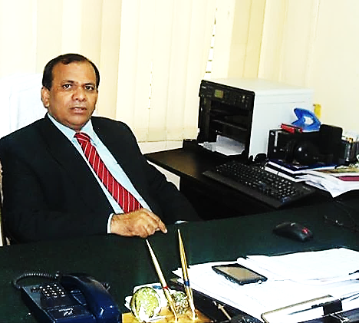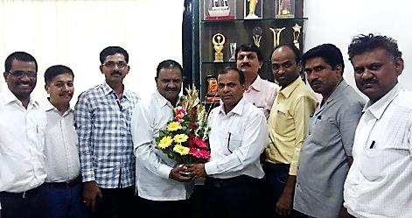
-------------------------------------------------------------------------------------------------------------------------
Quantum Materials in the Microwave and Optical Ranges
Alexandre M Zagoskin, Didier Felnacq, and Emmanuel Rousseau
EPJ Quntum Technology 2016 3:2 / DOI: 10.1140/epjqt/s40507 – 016 – 0040 – x

Quantum materials generalize the concept of metamaterials (artificial optical media) to the case when their optical properties are determined by the interplay of quantum effects in the constituent ‘artificial atoms’ with the electromagnetic field modes in the system. The theoretical investigation of these structures demonstrated that a number of new effects (such as quantum birefringence, strongly non-classical states of light, etc.) are to be expected, prompting the efforts on their fabrication and experimental investigation. These authors provided a summary of the principal features of quantum metamaterials and reviewed the current state of research in this quickly developing field, which bridges quantum optics, quantum condensed matter theory and quantum information processing.
==================================================================================

Facts about Vitamin – D
- Vitamin D prevents osteoporosis, depression, prostate cancer, breast cancer, and even affects diabetes and obesity.
- Vitamin D is perhaps the single most underrated nutrient in the world of nutrition. That's probably because it's free: your body makes it when sunlight touches your skin.
Fifteen facts those are important to know about vitamin D and sunlight exposure:
1. Vitamin D is produced by your skin in response to exposure to ultraviolet radiation from natural sunlight.
2. The healing rays of natural sunlight (that generate vitamin D in your skin) cannot penetrate glass. So you don't generate vitamin D when sitting in your car or at home.
3. It is nearly impossible to get adequate amounts of vitamin D from your diet. Sunlight exposure is the only reliable way to generate vitamin D in your own body.
4. A person would have to drink ten tall glasses of vitamin D fortified milk each day just to get minimal levels of vitamin D into their diet.
5. The further you live from the equator, the longer the exposure you need from the sun in order to generate vitamin D. Canada, the U.K. and most U.S. states are far from the equator.
6. People with dark skin pigmentation may need 20 - 30 times as much exposure to sunlight as fair-skinned people, to generate the same amount of vitamin D. That's why prostate cancer is epidemic among black men - it's a simple, but widespread, sunlight deficiency.
7. Sufficient levels of vitamin D are crucial for calcium absorption in your intestines. Without sufficient vitamin D, your body cannot absorb calcium, rendering calcium supplements useless.
8. Chronic vitamin D deficiency cannot be reversed overnight: it takes months of vitamin D supplementation and sunlight exposure to rebuild the body's bones and nervous system.
9. Even weak sunscreens (SPF=8) block your body's ability to generate vitamin D by 95%. This is how sunscreen products actually cause disease - by creating a critical vitamin deficiency in the body.
10. It is impossible to generate too much vitamin D in your body from sunlight exposure: your body will self-regulate and only generate what it needs.
11. If it hurts to press firmly on your sternum, you may be suffering from chronic vitamin D deficiency right now.
12. Vitamin D is "activated" in your body by your kidneys and liver before it can be used.
13. Having kidney disease or liver damage can greatly impair your body's ability to activate circulating vitamin D.
14. The sunscreen industry doesn't want you to know that your body actually needs sunlight exposure because that realization would mean lower sales of sunscreen products.
15. Even though vitamin D is one of the most powerful healing chemicals in your body, your body makes it absolutely free. No prescription required.
On the issue of sunlight exposure, by the way, it turns out that super antioxidants greatly boost your body's ability to handle sunlight without burning. Astaxanthin is one of the most powerful "internal sunscreens" and can allow you to stay under the sun twice as long without burning.
Other powerful antioxidants with this ability include super fruits like Acai, Pomegranates (POM Wonderful juice), blueberries, etc.
Diseases and conditions cause by vitamin D deficiency:
- Osteoporosis is commonly caused by a lack of vitamin D, which greatly impairs calcium absorption.
- Sufficient vitamin D prevents prostate cancer, breast cancer, ovarian cancer, depression, colon cancer and schizophrenia.
- "Rickets" is the name of a bone-wasting disease caused by vitamin D deficiency.
- Vitamin D deficiency may exacerbate type 2 diabetes and impair insulin production in the pancreas.
- Obesity impairs vitamin D utilization in the body, meaning obese people need twice as much vitamin D.
- Vitamin D is used around the world to treat Psoriasis.
- Vitamin D deficiency can cause schizophrenia.
- Seasonal Affective Disorder is caused by a melatonin imbalance initiated by lack of exposure to sunlight.
- Chronic vitamin D deficiency is often misdiagnosed as fibromyalgia because its symptoms are so similar: muscle weakness, aches and pains.
- Your risk of developing serious diseases like diabetes and cancer is reduced 50% - 80% through simple, sensible exposure to natural sunlight 2-3 times each week.
===========================================================================

Recent Advances in Nanotechnology Applied to Biosensors

To date, modern materials science has reached a high degree of sophistication. As a result of continuous progress in synthesizing and controlling materials on the submicron and nanometer scales, novel advanced functional materials with tailored properties can be created. When scaled down to a nano-scale, most materials exhibit novel properties that cannot be extrapolated from their bulk behavior. The interdisciplinary boundary between materials science and biology has become a fertile ground for new scientific and technological development. For the fabrication of an efficient biosensor, the selection of substrate for dispersing the sensing material decides the sensor performance. Various kinds of nanomaterials, such as gold nanoparticles, carbon nanotubes (CNTs), magnetic nanoparticles and quantum dots, are being gradually applied to biosensors because of their unique physical, chemical, mechanical, magnetic and optical properties, and markedly enhance the sensitivity and specificity of detection.

Nanomaterials-based biosensors, which represent the integration of material science, molecular engineering, chemistry and biotechnology, can markedly improve the sensitivity and specificity of biomolecule detection, hold the capability of detecting or manipulating atoms and molecules, and have great potential in applications such as bio-molecular recognition, pathogenic diagnosis and environment monitoring. Janssen et al., demonstrated that a rotating magnetic field can be used to apply a controlled torque on super paramagnetic beads which leads to a tunable bead rotation frequency in fluid and develop a quantitative model, based on results from a comprehensive set of experiments. This control of torque and rotation will enable novel functional assays in bead-based biosensors.

Since Iijima discovered carbon nanotubes (CNTs) in 1991, CNTs have attracted enormous interest due to their many novel properties such as unique mechanical, physical, chemical properties. CNTs have great potential in applications such as nano-electronics, biomedical engineering, and bio-sensing and bio-analysis. For example, polymer-CNTs composites can achieve high electrical conductivity and good mechanical properties, which offer the exciting possibility of developing ultrasensitive, electrochemical biosensors.

Conductive polymer-based nano-composite has been utilized as a MEMS sensing material via a one-step, selective on-chip deposition process at room temperature. For example, the doped PPy MWCNT is confirmed to be sensitive to glucose concentrations up to 20 mM, which covers the physiologically important 0-20 mM range for diabetics, so they can be used for diagnosis of diabetes. So far, these electrochemical sensors such as enzyme-based biosensors, DNA sensors and immunosensors have been developed based on polymer-CNT composites, and can be used to diagnose different kinds of diseases quickly.
Source: Sensors 2009, 9, 1033-1053; doi: 10.3390/s90201033
-------------------------------------------------------------------------------------------------------------------------------------
Invisible ‘second skin’ polymer material temporarily tightens skin - May 9, 2016
Scientists at MIT, Massachusetts General Hospital, Living Proof, and Olivo Labs have developed a new material that can temporarily protect and tighten skin, and smooth wrinkles. With further development, it could also be used to deliver drugs to help treat skin conditions such as eczema and other types of dermatitis.
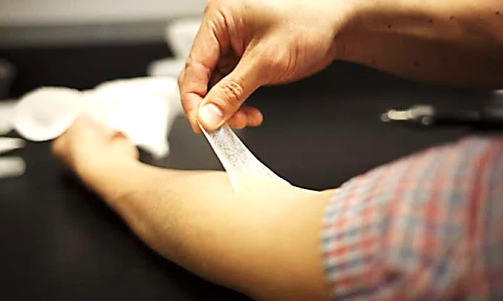
The material, a silicone-based polymer that could be applied on the skin as a thin, imperceptible coating, mimics the mechanical and elastic properties of healthy, youthful skin. In tests with human subjects, the researchers found that the material was able to reshape “eye bags” under the lower eyelids and also enhance skin hydration. This type of “second skin” could also be adapted to provide long-lasting ultraviolet protection, the researchers say.

“It’s an invisible layer that can provide a barrier, provide cosmetic improvement, and potentially deliver a drug locally to the area that’s being treated. Those three things together could really make it ideal for use in humans,” says Daniel Anderson, an Associate Professor in MIT’s Department of Chemical Engineering and a Member of MIT’s Koch Institute for Integrative Cancer Research and Institute for Medical Engineering and Sciences (IMES).

Anderson is one of the authors of a paper describing the polymer in the May 9, 2016 online issue of Nature Materials. Robert Langer, the David H. Koch Institute Professor at MIT and a member of the Koch Institute is the paper’s senior author, and the paper’s lead author is Betty Yu SM’98 ScD’02, former Vice-President at Living Proof. Langer and Anderson are co-founders of Living Proof and Olivo Labs, and Yu earned her Master’s and Doctorate at MIT.

Mimicking Skin
As skin ages, it becomes less firm and less elastic – problems that can be exacerbated by Sun exposure. This impairs skin’s ability to protect against extreme temperatures, toxins, microorganisms, radiation, and injury. About 10 years ago, the research team set out to develop a protective coating that could restore the properties of healthy skin, for both medical and cosmetic applications. “We started thinking about how they might be able to control the properties of skin by coating it with polymers that would impart beneficial effects. We also wanted it to be invisible and comfortable,” Anderson says.
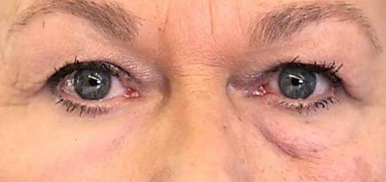 The researchers created a library of more than 100 possible polymers, all of which contained a chemical structure known as siloxane – a chain of alternating atoms of silicon and oxygen. These polymers can be assembled into a network arrangement known as cross – linked polymer (XPL). The researchers then tested the material in search of one that would best mimic the appearance, strength, and elasticity of healthy skin.

Read more at: http://phys.org/news/2016-05-invisible-skin-polymer-material-temporarily html#jCp
------------------------------------------------------------------------------------------------------------------------------------
Ferromagnetism + Semiconductor = Spintronics: New opportunities for improving electronics (May 9, 2016).

More, faster, better, cheaper. These are the demands of our device-happy and data-centered world. Meeting these demands requires technologies for processing and storing information. Now, a significant obstacle to the development of next-generation device technologies appears to have been overcome, according to researchers from the University of Tokyo (Japan), Tokyo Institute of Technology (Japan) and Ho Chi Minh University of Pedagogy (Vietnam).
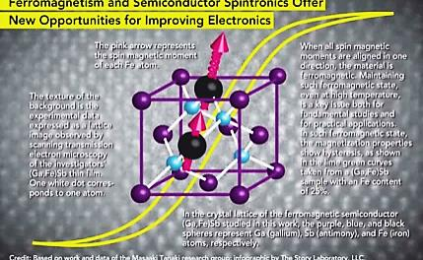 Specializing in the emerging field of semiconductor spintronics, the team has become the first to report growing iron-doped ferromagnetic semiconductors working at room temperature – a longstanding physical constraint. Doping is the practice of adding atoms of impurities to a semiconductor lattice to modify electrical structure and properties. Ferromagnetic semiconductors are valued for their potential to enhance device functionality by utilizing the spin degrees of freedom of electrons in semiconductor devices.
“Bridging semiconductor and magnetism is desirable because it would provide new opportunities of utilizing spin degrees of freedom in semiconductor devices,” explained research leader Masaaki Tanaka, Ph.D., of the Department of Electrical Engineering & Information Systems, and Center for Spintronics Research Network, University of Tokyo. “Our approach is, in fact, against traditional views of material design for ferromagnetic semiconductors. In our work, we have made a breakthrough by growing an iron-doped semiconductor which shows ferromagnetism up to room temperature for the first time in semiconductors that have good compatibility with modern electronics. Our results open a way to realize semiconductor spintronic devices operating at room temperature.”

The researchers discuss their findings this week in Applied Physics Letters. The researchers’ maverick move challenged the prevailing theory that predicted a type of semiconductor known as “wide band gap” would be strongly ferromagnetic. Most research focuses on the wide band gap approach. “We instead chose narrow-gap semiconductors, such as indium arsenide, or gallium antimonide, as the host semiconductors,” Tanaka said. This choice enabled them to obtain ferromagnetism and conserve it at room temperature by adjusting doping concentrations.

Investigators have long envisioned bridging semiconductors and magnetism to create new opportunities of utilizing spin degrees of freedom and harnessing electron spin in semiconductors. But until now, ferromagnetic semiconductors have only worked under experimental conditions at extremely low, cold temperatures, typically lower than 200 K (-73ºC), which is much colder than the freezing point of water, 273.15 K. Here, K (Kelvin) is a temperature scale which, like the Celsius (ºC) scale, has 100 degrees between boiling (373.15 K = 100ºC) and freezing (273.15 K = 0ºC) of water.

Potential applications of ferromagnetic-semiconductors include designing new and improved devices, such as spin transistors.

"Spin transistors are expected to be used as the basic element of low-power-consumption, non-volatile and reconfigurable logic circuits," Tanaka explained.
In 2012, the team postulated that using iron as magnetic doping agents in semiconductors would produce performance advantages not seen in the more frequently studied manganese class of dopants.
Skeptics doubted this approach, but the team continued and successfully created a ferromagnetic semiconductor known as "n-type."

"This was thought impossible by almost all leading theorists," Tanaka noted. "They predicted that such n-type ferromagnetic semiconductors cannot retain ferromagnetism at temperatures higher than 0.1 K. We demonstrated, however, much new functionality, such as the quantum size effect and the ability to tune ferromagnetism by wave function manipulation."
On a practical level, the team continues its research with the goal of applying iron-doped ferromagnetic semiconductors to the field of spintronic device innovation. On a theoretical level, the team is interested in re-evaluating conventional theories of magnetism in semiconductors. "Based on the results of many experimental tests, we have proven that ferromagnetism in our iron-doped semiconductor is intrinsic," Tanaka said.
More information: "High-temperature ferromagnetism in heavily Fe-doped ferromagnetic semiconductor (Ga, Fe) Sb," Applied Physics Letters, DOI: 10.1063/1.4948692
Journal reference: Applied Physics Letters / Provided by: American Institute of Physics
Read more at: http://phys.org/news/2016-05-ferromagnetism -semiconductor-spintronics-opportunities-electronics.html#jCp
----------------------------------------------------------------------------------------------------------------
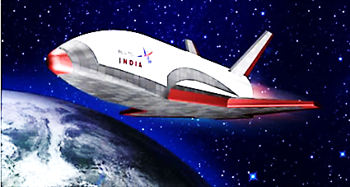
ISRO to test launch
RLV Technology Demonstrator
On May 23, 2016

It will be a major breakthrough in space exploration and space utilization. A reusable launch vehicle is the unanimous solution to achieve low – cost, reliable and on – demand space access. It would be a Reusable Launch Vehicle Technology Demonstrator Hypersonic Experiment (RLV-TD HEX1) wherein the hypersonic aero-thermo dynamic characterization of winged re-entry body along with autonomous mission management to land at a specified location and characterization of hot structures are planned to be demonstrated. This would be followed by the landing experiment (LEX), return flight experiment (REX) and scramjet propulsion experiment (SPEX).
Indian Defence News
--------------------------------------------------------------------------------------------------------------------------
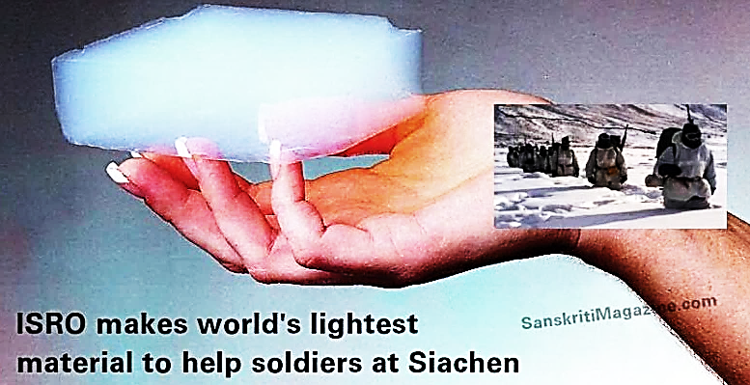 IISRO has manufactured a product to make uniforms for the Indian Army Soldiers at Siachen and other places with extreme conditions. Vikram Sarabhai Space Centre, Thruvananthapuram, Kerala has manufactured silica aerogel, also known as Blue-Air, which is the lightest material in the world. The initiative comes following the pathetic death of Lance Naik Hanumanthappa and many other soldiers who lost their lives at Siachen recently.
- Silica aerogel is also known as ‘frozen smoke’ for its lightness.
- Silica aerogel or Blue Air has a density of 1, 000 g/M³, which makes it even lighter than air, which weighs 1, 200 g/M³ at 20ºC, at sea-level.
- Silica aerogel had 15 Guinness World Records entries as the lowest-density solid and the best insulator till 2011.
- Although, it was ousted by aerographite in 2012 and aerographene in 2013, silica aerogel is the lightest material with a commercial value.
- Silica aerogel can also be used in rocket engines for insulation.
By Sanskrit on May 8, 2016
---------------------------------------------------------------------------------------------------------------------
AMAGING SCIENTISTS
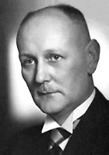 Gerhard Domagk
Gerhard was born in 1895 in Germany. After acting first as soldier and then medic in the First World War, Gerhard qualified as a doctor upon his return to Germany. In 1923, he began lecturing on Pathological Anatomy, earning his post-doctoral degree from the University of Griefswald in 1924. It was in 1927, that he began researching bacteriology at the I. G. Farbenindustrie laboratories.

In 1932, Gerhard successfully isolated dimethyl benzyl dodecyl ammonium chloride, a chemical that could be used to disinfect skin and medical instruments. Its launch on the market was a success, leading to more research work for Gerhard. He moved on to study the effects of chemical dyes on diseases, becoming director of the Bayer Institute. Through his research, Gerhard realized that mice infected with the infection streptococcus survived if they were treated with a particular dye. It was named Prontosil.

Then in 1933, tragedy struck Gerhard family. His only daughter was infected with erysipelas – an infection of the hand. At the time, the only cure was to amputate. Gerhard decided to risk treating his daughter with the newly discovered Prontosil. It was a success and Gerhard’s daughter made a full recovery.

Gerhard published his findings in 1935. Research carried out at the Pasteur Institute showed that it was not the dye itself that treated the infections, but rather a chemical found within the dye – sulphonamide, the first antibiotic. Prontosil was then used to treat a variety of bacterial infections, including throat infections, meningitis, puerperal fever, pnuemonia and erysipelas.

Work soon began on the treatment of tuberculosis and cancer, including more study into other chemotherapy options. Gerhard continued with chemical and bacterial research for the remainder of his career and also travelled the world to lecture. His work ensured humanity had the best chance of survival that medicine could provide.

Gerhard was awarded a Nobel Prize for Medicine in 1939 and made a Knight of the Order Of Merit in 1952. He received the Spanish Grand Cross of the Civil Order of Health in 1955, followed by the Paul Ehrlich Gold Medal and Paul Ehrlich Prize in 1956. In 1958, Gerhard was awarded a professorial role in Pathological Anatomy at the University of Munster.

Gerhard received several honorary doctorates from many universities, including Munster, Lima and Buenos Aires. He was elected as a foreign member of the British Academy of Science and also as a Fellow of the Royal Society, both in 1959. The Royal Society published his biography in 1964. Gerhard was made a member of the German Dermatological Society in 1960 and awarded a Japanese Order of Merit of the Rising Sun in the same year.
Source: Amazing Scientists Inspirational Stories by Dr. Charles Margerison, The Amazing People Club, Viewpoint Resources Ltd., England, ISBN 978 – 1 – 921752 – 43 – 8.
--------------------------------------------------------------------------------------------------------------------
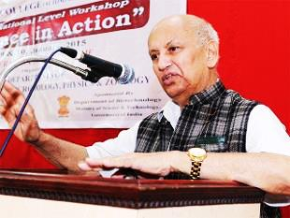 Prof. U. R. Rao, a renowned space scientist and previous Chairman, ISRO & Secretary, Department of Space, Govt. of India will be honored by the International Astronautical Federation (IAF) with the 2016 “IAF Hall of Fame” award for his outstanding contributions to the progress of Astronautics and the Federation.

The IAF Hall of Fame consists of a permanent gallery of these personalities, including a citation, biographical information and a picture, in a special part of the web presence.
This year’s 67th International Astronautical Congress will be held in Guadalajara, Mexico, during September 26 – 30, 2016.
Source: The Economic Times, May 16, 2016.
---------------------------------------------------------------------------------------------------------------------
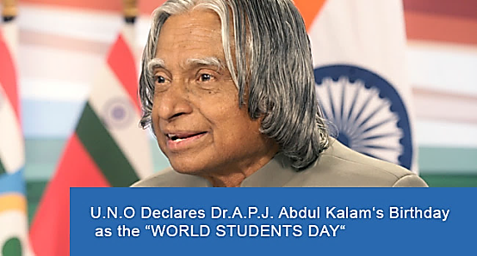 PTI – In the year 2010 United Nations decided to mark the importance of India’s former President and great scientist Dr. A. P. J. Abdul Kalam, and declared his birthday (October, 15th) as ‘World Students Day’.
October, 15th

Source: News World India / New Delhi/ Updated on October 28, 2015.
---------------------------------------------------------------------------------------------------------------------
NASA just released 56 patented space and rocket technologies to the public.
This week, NASA released 56 of its patented technologies into the public domain, including a super-cheap method for manufacturing carbon nanotubes and a stronger type of aerogel, new propulsion methods and engine technologies for rockets, and devices that could one day help humans live and breathe in space.
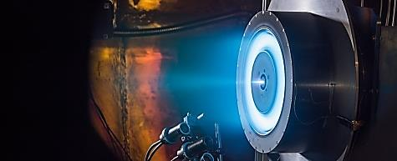 http://www.sciencealert.com/nasa-just-released-56-patented- space - and –rocket-technologies- to – the – public
--------------------------------------------------------------------------------------------------------------------------------
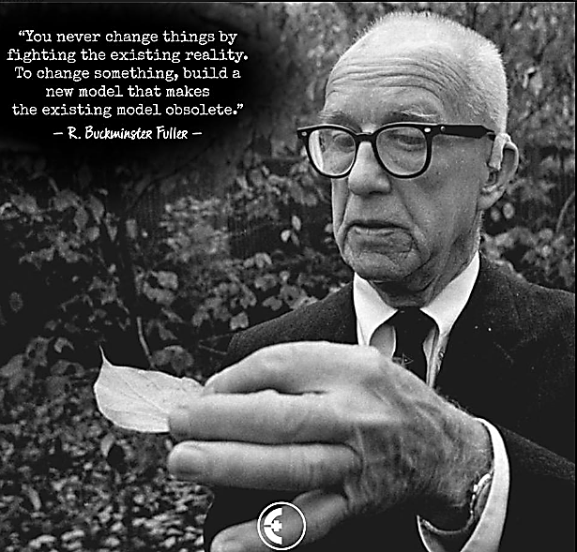
Polyciclic Polyprenylated Derivatives from Hypericum urlum: Neuroprotective Effets and Antidepressant-like Activity of Uralodin - A
Zhong-Bo Zhou, Zhong-Rui Li, Xiao-Bing Wang, Jian-Guang Luo, and Ling-Yi-Kong
State Key Laboratory of Natural Medicines, Department of Natural Medicinal Chemistry, China Pharmaceutical University, 24 Tong Jia Xiang, Nanjing 210009, People’s Republic of China
J. Nat. Prod. , Article ASAP; DOI: 10.1021/acs.jnTPROD.5B00667 / Publication Date (Web) May 5, 2016
The isolation of the new polycyclic polyprenylated acylphloroglucinols uraliones A-K (1 – 11) together with the known analogues (12 – 16) from a whole Hypericum uralum plant was reported. The structures of these compounds were established through spectroscopic methods, X-ray diffraction analysis was used to confirm the absolute configuration of 1. The
protectiv effects of the isolates against corticosterone-induced PC12 cell injury were assessed. Except for compound 9, all tested compounds exhibited significant effects against induced injury in PC12 cells Uralodin A (14), orally administered in doses of 13 and 26 mg/kg
exhibited antidepressant-like activity in the tail suspension and forced – swimming tests in mice.

-------------------------------------------------------------------------------------------------------------------------
Effect of Vitamin-C on Blood Glucose and Glycosylated Hemoglobin in Type-II Diabetes Mellitus

World Journal of Analytical Chemistry, 2015, Vol. 3, No. 1A, 6-8 Available online at http://pubs.sciepub.com/wjac/3/1A/2 © Science and Education Publishing DOI: 10.12691 /wjac-3-1A-2

Ashraf kotb1*, Khaldun M. Al Azzam2
¹ Department of Physiology, Medicine program, Batterjee Medical College for Sciences and Technology (BMC), 21442 Jeddah, Kingdom of Saudi Arabia
² Department of Pharmaceutical Chemistry, Pharmacy Program, Batterjee Medical College for Sciences and Technology (BMC), 21442 Jeddah, Kingdom of Saudi Arabia
*Corresponding author: drashrafsalem@hotmail.com
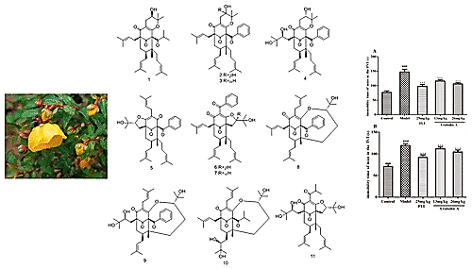

Ascorbic acid (vitamin C) is an antioxidant which is hypothesized to have an effect on the blood glucose in patients with type II diabetes. The aim of the study is to examine the effect of oral vitamin C on fasting blood glucose (FBG), two hours postprandial blood glucose (PPBG) as well as glycosylated hemoglobin (HbA1c) in the treatment of type 2 diabetes mellitus (DM). One hundred patients participated in this study were divided into two groups. The first group was the control group contained fifty normal patients. The second group contained fifty patients having type II DM and given the drug Glucophage at a dose of 2000 mg/day beside healthy diet to control diabetes. They were left for three months then the blood samples were collected from both groups to detect the FBG, two hours PPBG and HbA1c. After that, the diabetic group was given beside the drug and diet treatment vitamin C drug (Vitacid calcium) 1000 mg orally three times /day for another three months. At the end of the three months, blood samples were collected from both groups to examine the FBG, two hours PPBG and the HbA1c. The diabetic group recorded a significantly higher level of FBG, two hours PPBG and HbA1c compared to the control group after the first three months. The diabetic group after being given vitamin C beside the drug and diet for three months recorded a significant decreased level of FBG, two hours PPBG, and HbA1c compared to the levels it recorded before without being given the vitamin C. In conclusion, oral supplementation of vitamin C reduces FBG, two hours PPBG, and improves HbA1c. Hence, its combination with diabetic drugs may be beneficial in the treatment of type II DM to maintain good glycemic control.
----------------------------------------------------------------------------------------------------------------------------
Forthcoming Events of ACT:
- “Teachers Training Program” at Pragati Engineering College, July, 2016.
- 3rd National Conference on New Renaissance in Chemical Research (NCNRCR – 2016), August, 19, 2016, Department of Chemistry, SRM University, Ramapuram Campus, Chennai.
- Workshop on “Instrumentation Technics for Research in Chemical Sciences,” Gulbarga University, Gulbarga, Karnataka, August 27th – 28th, 2016.
- Workshop on “Instrumentation Technics for Research in Chemical Sciences,” Dept. of Chemistry, College of Arts, Sciences, and Humanities, Modi Institute of Science & Technology, Lakshmangarh, Sikar – 332 311, Rajasthan (Slated for the 3rd week of September, 2016).
- Seminar on “Advanced Technologies for the future,” Engineering College, Gayatri Group of Institutions, Visakhapatnam, Andhra Pradesh (September, 2016).
- National Convention of Chemistry Teachers (NCCT – 2016), October 21- 23, 2016, Raja N. L. Khan’s Women’s College, Midnapore.
----------------------------------------------------------------------------------------------------------
The following ACT – Awards will be given during NCCT-2016:
- Life - Time Achievement Award to a superannuated teacher for outstanding contributions to Chemistry Education & research. This year, the award will be given to a teacher from East Zone as recommended by the zone.
- Shri Anupam Sinha Best Chemistry Teacher Award
- Best Woman Chemistry Teacher Award
- Prof. Lallan Singh Award for best P. G. Chemistry Teacher.
- Prof. R. P. Singh Award for outstanding contributions to Chemistry Education.

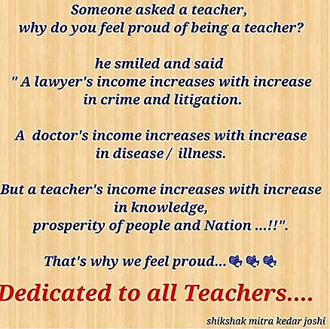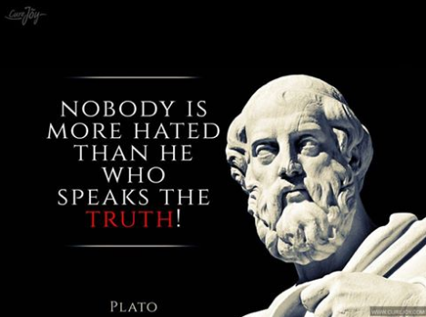
===========================================================================
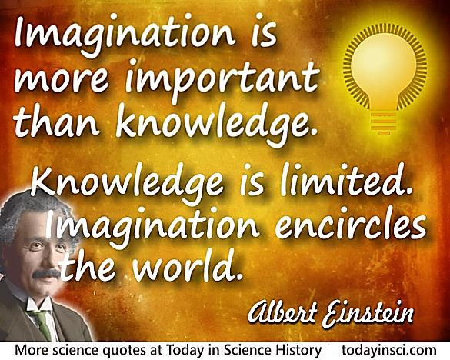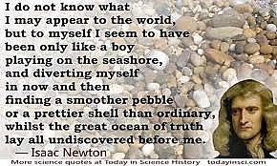
===========================================================================
Editorial Board:
Dr. M. R. R. Prasad, Editor –in - Chief
Dr. D. C. Deka Dr. Subhash P. Singh Dr. Altaf Pandit
Dr. (Mrs.) Helen Kavitha Dr. P. V. S. Machiraju Dr. K. Sudhakar Babu
===========================================================================

